VDOE Regions 5, 6 & 7 Educational Interpreter Grant
Virtual Interpreting: How to Prepare and Deliver Effectively
Date: November 7, 2020 Time: 9:00 am-4:00 pm
0.6 RID CEUs Sponsored by VRID
Location Virtual online workshop
COST: VRID Members - $50 / Non-Members $60 / Student $25 / VDOE Participants $0
Workshop Description: This workshop will focus on the changing role of the interpreter using a virtual format. With the changing world interpreters across the country have been forced to interpret online. This workshop will take a look at programs that have been successful in supporting interpreters. The challenge of teaming using virtual formats will also be discussed. The participants will have the opportunity to interpret material and practice how to record and download their products and make them shareable. Interpreters will also discuss the impact of virtual learning on the clients we serve. Some of the programs we will be using are Zoom, Google duo, QuickTime, and Loom. Others will be discussed as well.
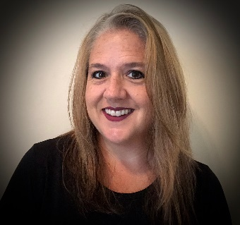
Presenter: Sabrina Smith

Sabrina Smith, PhD, has been involved in the interpreting field forever 20 years. She is Nationally certified through RID: CI and CT, as well as NIC Master and Ed:K-12. She works as an educational interpreter and has been interpreting in the school system for over19 years. She also works as a video relay interpreter with Sorenson Communications where she has been employed over13 years. She enjoys encouraging interpreters of all levels and mentoring people across the United States. She works as a freelance interpreter, and as a performing arts interpreter furtherer’s and concert venues in her area. She has presented various workshops across the country. Feel free to contact her about mentoring, presenting, or just general questions about the field of interpreting at sabrinatempie.wixsite.com/aslterp.
This workshop is presented at no cost to K-12 interpreters. To register, go to VRID.org and click on the workshop link. Grant participants should contact Kathy Campbell, Kathy.campbell@vsdb.k12.va.us for the training code. VRID is an Approved RID CMP Sponsor for Continuing Education Activities. This Professional Studies program is offered for 0.6 CEUs at the Little/None Content Knowledge Level. If you require a reasonable accommodation for this event, please contact Kathy Campbell by October 31, 20.

