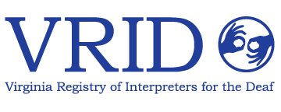

**Northern Virginia Community College**

**And**

**VDOE Educational Interpreter Training Grant provided by Marla Pollack**

**Presents**

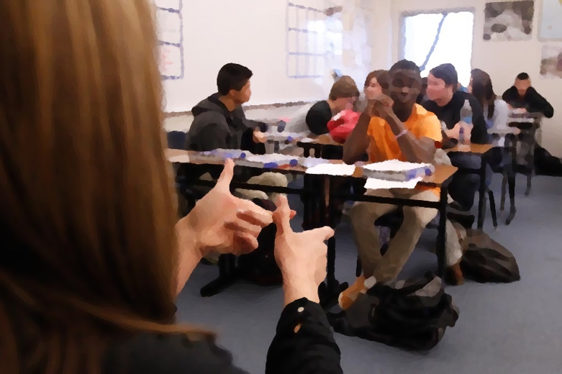

“Building Relationships and Understanding Ethics in Educational Interpreting”

**Sabrina Smith, PhD**

**When:** Wednesday August 12, 2020

**Where:** Virtual workshop via Zoom, register: <https://vrid.wildapricot.org/event-3908324>

**Location:** A link will be sent you once you register

**Time:** 9:00 AM-4:00 PM

**CEUs: 0.6 CEUs**

**Contact:** **Paula Debes Reece Marla Pollack**

703-232-3192 571-982-1504

[preece@nvcc.edu](mailto:preece@nvcc.edu) [mspollack@fcps.edu](mailto:mspollack@fcps.edu)

**Registration:**

If you are a grant participant or student you will be asked to obtain a code from me to register at no cost: [mspollack@fcps.edu](mailto:mspollack@fcps.edu)

Registration due: august 12, 2020

**"VRID is an Approved RID CMP Sponsor for Continuing Education Activities.**

**This Professional Studies program is offered for 0.6 CEUs at the Little/None Content Knowledge Level."**

**"If you require a reasonable accommodation for this event, please contact Marla Pollack or Paula Debes Reece by August 2, 2020**

“Building Relationships and Understanding Ethics in Educational Interpreting”

**Description:**

This workshop deals with ethics in interpreting and will focus specifically on educational interpreters. Interpreters will learn how to transition smoothly into a class making teachers feel less anxiety about having an adult in their classroom. The participants will learn techniques that help build a strong working relationship with other coworkers at the same time. Interpreters take a look at how their actions can interfere with the ability to get the respect they want. They learn to apply new techniques and approaches to get materials they need before the school year begins.

The role of the interpreter is discussed in depth as well as how to approach others about our role. The goal is to become empowered as professionals starting from the basics “Dressing for success” and leading you to some of our biggest challenges “Please do not interpret everything I say”. Interpreters will devise techniques to educate the staff in the building about their roles as interpreters. Interpreters will also reflect on successful approaches as well as learn from the unsuccessful approaches that they have experienced in the past by sharing with their peers and having open discussions.

It not only deals with educational interpreting but it also helps prepare interpreters for National Certification testing. Interpreters will formulate ways to approach difficult scenarios by working from the Perceptions Model in order to practice applying ethics to the situations that may be faced in educational interpreting. It's a combination of lecture and hands on. Experiences are shared in this workshop and group discussions allow for peer feedback during the ethical practice segment.

**Presenter: Sabrina Smith, Ph.D**

Sabrina Smith, PhD, has been involved in the interpreting field for over 20 years. She is Nationally certified through RID: CI and CT, as well as NIC Master and Ed:K-12. She works as an educational interpreter and has been interpreting in the school system for over 19 years. She also works as a video relay interpreter with Sorenson Communications where she has been employed over 13 years. She enjoys encouraging interpreters of all levels and mentoring people across the United States. She works as a freelance interpreter, and as a performing arts interpreter for theatre’s and concert venues in her area. She has presented various workshops across the country. Feel free to contact her about mentoring, presenting, or just general questions about the field of interpreting at sabrinatempie.wixsite.com/aslterp